VISVESVARAYA TECHNOLOGICAL UNIVERSITY

“JnanaSangama”, Belgaum -590014, Karnataka.



LAB REPORT

on

Artificial Intelligence (23CS5PCAIN)

Submitted by Srikar R Olety(1BM22CS289)

in partial fulfillment for the award of the degree of

# BACHELOR OF ENGINEERING

in

COMPUTER SCIENCE AND ENGINEERING



B.M.S. COLLEGE OF ENGINEERING

(Autonomous Institution under VTU)

BENGALURU-560019

Sep-2024 to Jan-2025

B.M.S. College of Engineering,

Bull Temple Road, Bangalore 560019

(Affiliated To Visvesvaraya Technological University, Belgaum)

## Department of Computer Science and Engineering



CERTIFICATE

This is to certify that the Lab work entitled “Artificial Intelligence (23CS5PCAIN)” carried out by Srikar R Olety(1BM22CS289), who is bonafide student of B.M.S. College of Engineering. It is in partial fulfillment for the award of Bachelor of Engineering in Computer Science and Engineering of the Visvesvaraya Technological University, Belgaum. The Lab report has been approved as it satisfies the academic requirements in respect of an Artificial Intelligence (23CS5PCAIN) work prescribed for the said degree.

|  |  |
| --- | --- |
| Rashmi H  Assistant Professor  Department of CSE, BMSCE | Dr. Kavitha Sooda  Professor & HOD  Department of CSE, BMSCE |

Index

|  |  |  |  |
| --- | --- | --- | --- |
| Sl. No. | Date | Experiment Title | Page No. |
| 1 | 30-9-2024 | Implement Tic –Tac –Toe Game Implement vacuum cleaner agent | 1 |
| 2 | 7-10-2024 | Implement 8 puzzle problems using Depth First  Search (DFS)  Implement Iterative deepening search algorithm | 5 |
| 3 | 14-10-2024 | Implement A* search algorithm | 17 |
| 4 | 21-10-2024 | Implement Hill Climbing search algorithm to solve N-Queens problem | 22 |
| 5 | 28-10-  2024 | Simulated Annealing to Solve 8Queens problem | 24 |
| 6 | 11-11-2024 | Create a knowledge base using propositional logic and show that the given query entails the knowledge base or not. | 27 |
| 7 | 2-12-2024 | Implement unification in first order logic | 31 |
| 8 | 2-12-2024 | Create a knowledge base consisting of irst order logic statements and prove the given query using forward reasoning. | 36 |
| 9 | 16-12-  2024 | Create a knowledge base consisting of irst order logic statements and prove the given query using Resolution | 40 |
| 10 | 16-12-2024 | Implement Alpha-Beta Pruning. | 43 |

Github Link: https://github.com/Srikar2507/AI_LAB

Program 1

Implement Tic –Tac –Toe Game

Implement vacuum cleaner agent

Algorithm:

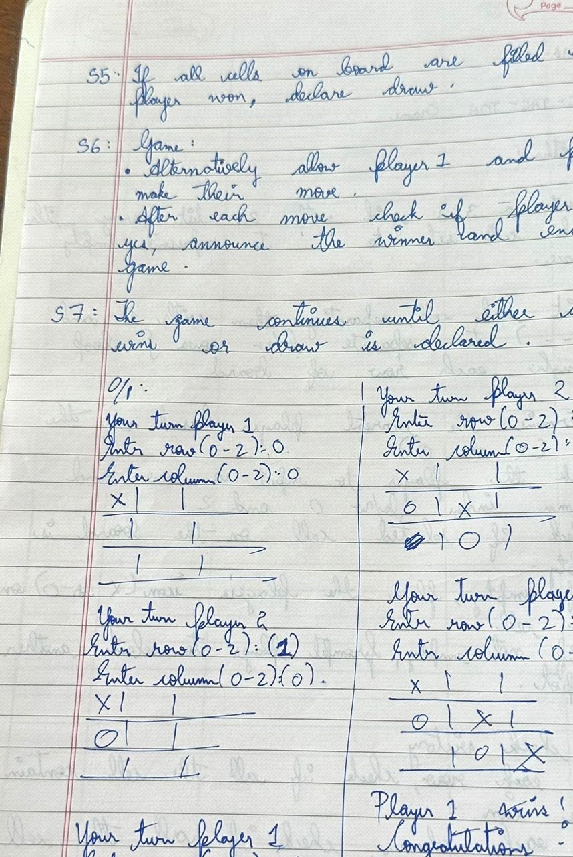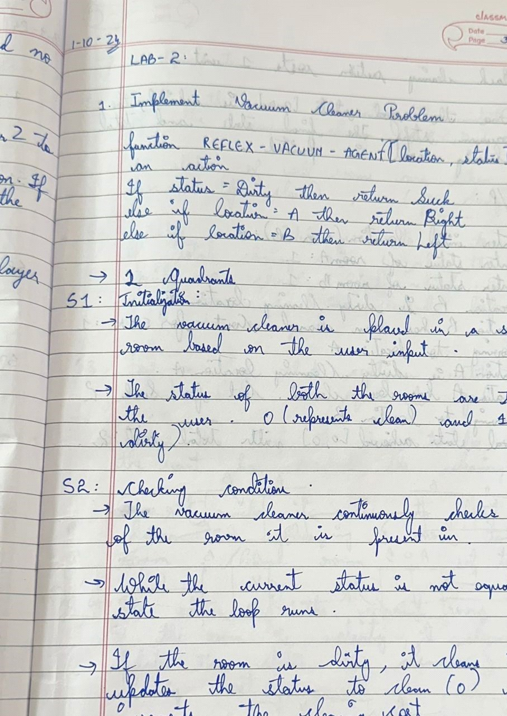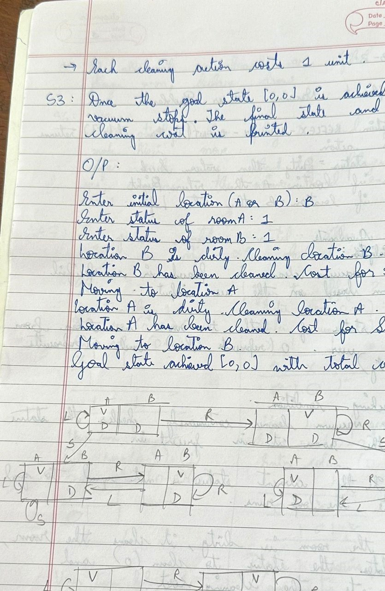

Code:

TicTacToe

board = [[' ' for _ in range(3)] for _ in range(3)] def draw_board(): for row in board:

print(' | '.join(row)) print('---------') def player_move(icon): if icon == 'X': number = 1 elif icon == 'O': number = 2

print("Your turn player {}".format(number))

row = int(input("Enter row (0-2): "))

col = int(input("Enter column (0-2): "))

if board[row][col] == ' ': board[row][col] = icon else:

print("That space is taken!") def is_victory(icon): for row in board: if all(cell == icon for cell in row):

return True for col in range(3): if all(board[row][col] == icon for row in range(3)):

return True if all(board[i][i] == icon for i in range(3)) or \ all(board[i][2-i] == icon for i in range(3)):

return True

return False def is_draw():

return all(cell != ' ' for row in board for cell in row) def play_game(): draw_board() while True: player_move('X') draw_board() if is_victory('X'):

print("Player 1 wins! Congratulations!")

break elif is_draw():

print("It's a draw!") break player_move('O') draw_board() if is_victory('O'):

print("Player 2 wins! Congratulations!")

break elif is_draw():

print("It's a draw!") break

play_game() Output:

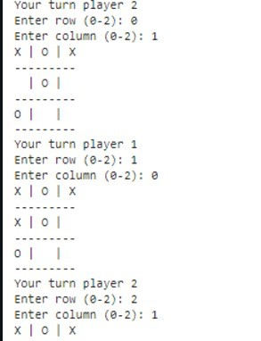

Vacuum World-2Quad:

class VacuumCleaner: def __init__(self, location, status):

self.location = location self.status = status self.goal_state = [0, 0] self.cost = 0

def clean(self): while self.status != self.goal_state: if self.location == 'A': if self.status[0] == 1: print("Location A is Dirty. Cleaning Location A.") self.status[0] = 0 self.cost += 1 print(f"Location A has been Cleaned. COST for SUCK: {self.cost}") else:

print("Location A is already clean.") print("Moving to Location B.") self.location = 'B'

elif self.location == 'B': if self.status[1] == 1: print("Location B is Dirty. Cleaning Location B.") self.status[1] = 0 self.cost += 1 print(f"Location B has been Cleaned. COST for SUCK: {self.cost}") else:

print("Location B is already clean.") print("Moving to Location A.")

self.location = 'A'

print(f"Goal state achieved: {self.status} with total cost: {self.cost}")

def get_user_input():

location = input("Enter initial location (A or B): ").strip().upper() a_status = int(input("Enter status of Room A (0 for clean, 1 for dirty): ")) b_status = int(input("Enter status of Room B (0 for clean, 1 for dirty): ")) return location, [a_status, b_status]

def main():

location, status = get_user_input() vacuum = VacuumCleaner(location, status) vacuum.clean()

main()

Output:

Output1

Enter initial location (A or B): A

Enter status of Room A (0 for clean, 1 for dirty): 1 Enter status of Room B (0 for clean, 1 for dirty): 0 Location A is Dirty. Cleaning Location A. Location A has been Cleaned. COST for SUCK: 1 Moving to Location B.

Goal state achieved: [0, 0] with total cost: 1

Output2

Enter initial location (A or B): A

Enter status of Room A (0 for clean, 1 for dirty): 1 Enter status of Room B (0 for clean, 1 for dirty): 1 Location A is Dirty. Cleaning Location A. Location A has been Cleaned. COST for SUCK: 1 Moving to Location B.

Location B is Dirty. Cleaning Location B. Location B has been Cleaned. COST for SUCK: 2 Moving to Location A.

Goal state achieved: [0, 0] with total cost: 2

Program 2

Implement 8 puzzle problems using Depth First Search (DFS)

Implement Iterative deepening search algorithm

Algorithm:

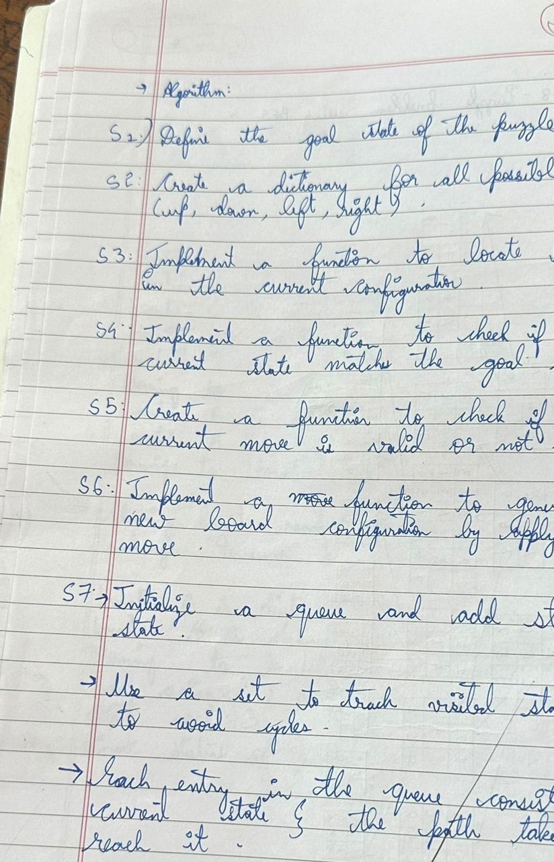

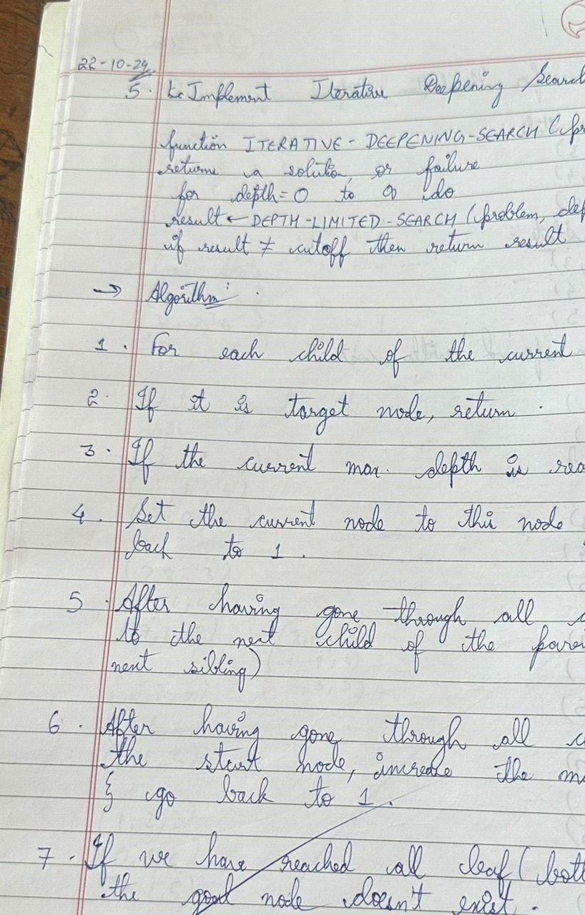

Code:

DFS: from copy import deepcopy

goal_state = [[0, 1, 2],

[3, 4, 5], [6, 7, 8]]

moves = {

'up': (-1, 0),

'down': (1, 0),

'left': (0, -1),

'right': (0, 1)

}

def find_blank(board): for i in range(3): for j in range(3): if board[i][j] == 0:

return i, j return None

def is_goal(state):

return state == goal_state

def is_valid_move(x, y):

return 0 <= x < 3 and 0 <= y < 3

def apply_move(board, move): x, y = find_blank(board) dx, dy = moves[move] new_x, new_y = x + dx, y + dy if is_valid_move(new_x, new_y): new_board = deepcopy(board) new_board[x][y], new_board[new_x][new_y] = new_board[new_x][new_y], new_board[x][y] return new_board

return None

def dfs(start): stack = [(start, [], 0)] # (state, path of moves, number of states explored) visited = set() explored_count = 0 # Count of unique states explored

while stack:

current_state, path, current_count = stack.pop()

if is_goal(current_state):

return path, explored_count # Return path of moves and explored count

# Create a unique representation of the state to store in visited state_tuple = tuple(tuple(row) for row in current_state) if state_tuple not in visited: visited.add(state_tuple) # Add to visited states explored_count += 1 for move in moves:

new_state = apply_move(current_state, move) if new_state: # Only consider valid new states

stack.append((new_state, path + [move], explored_count)) # Store the path and current count

return None, explored_count # Return explored count if no solution is found

def print_board(board): for row in board: print(row)

print()

def print_solution(solution, explored_count): if solution is not None:

print(f"Goal achieved with the following moves:")

current_board = initial_state for move in solution:

print(f"Move: {move}") current_board = apply_move(current_board, move)

print_board(current_board) print(f"Total number of states explored: {explored_count}") else:

print("No solution found")

initial_state = [[1, 2, 5],

[3, 4, 8], [6, 7, 0]]

solution, explored_count = dfs(initial_state)

print_solution(solution, explored_count)

Iterative deepening Search: from copy import deepcopy

DIRECTIONS = [(-1, 0), (1, 0), (0, -1), (0, 1)]

class PuzzleState: def __init__(self, board, parent=None, move=""):

self.board = board self.parent = parent

self.move = move

def get_blank_position(self):

for i in range(3): for j in range(3): if self.board[i][j] == 0:

return i, j

def generate_successors(self): successors = [] x, y = self.get_blank_position()

for dx, dy in DIRECTIONS:

new_x, new_y = x + dx, y + dy

if 0 <= new_x < 3 and 0 <= new_y < 3: new_board = deepcopy(self.board) new_board[x][y], new_board[new_x][new_y] = new_board[new_x][new_y], new_board[x][y] successors.append(PuzzleState(new_board, parent=self))

return successors

def is_goal(self, goal_state):

return self.board == goal_state

def __str__(self):

return "\n".join([" ".join(map(str, row)) for row in self.board])

def depth_limited_search(current_state, goal_state, depth):

if depth == 0 and current_state.is_goal(goal_state):

return current_state

if depth > 0: for successor in current_state.generate_successors():

found = depth_limited_search(successor, goal_state, depth - 1) if found: return found

return None

def iterative_deepening_search(start_state, goal_state):

depth = 0 while True:

print(f"\nSearching at depth level: {depth}") result = depth_limited_search(start_state, goal_state, depth) if result: return result

depth += 1

def get_user_input(): print("Enter the start state (use 0 for the blank):") start_state = [] for _ in range(3):

row = list(map(int, input().split())) start_state.append(row)

print("Enter the goal state (use 0 for the blank):") goal_state = [] for _ in range(3):

row = list(map(int, input().split())) goal_state.append(row)

return start_state, goal_state

def main():

start_board, goal_board = get_user_input() start_state = PuzzleState(start_board)

goal_state = goal_board

result = iterative_deepening_search(start_state, goal_state)

if result:

print("\nGoal reached!")

path = [] while result:

path.append(result) result = result.parent path.reverse() for state in path: print(state, "\n") else:

print("Goal state not found.")

if __name__ == "__main__": main()

Output:

Goal achieved with the following moves:

Move: left

[1, 2, 5]

[3, 4, 8]

[6, 0, 7]

Move: left

[1, 2, 5]

[3, 4, 8]

[0, 6, 7]

Move: up

[1, 2, 5]

[0, 4, 8]

[3, 6, 7]

Move: right

[1, 2, 5]

[4, 0, 8]

[3, 6, 7]

Move: right

[1, 2, 5]

[4, 8, 0]

[3, 6, 7]

Move: down

[1, 2, 5]

[4, 8, 7]

[3, 6, 0]

Move: left

[1, 2, 5]

[4, 8, 7]

[3, 0, 6]

Move: left

[1, 2, 5]

[4, 8, 7]

[0, 3, 6]

Move: up

[1, 2, 5]

[0, 8, 7]

[4, 3, 6]

Move: right

[1, 2, 5]

[8, 0, 7]

[4, 3, 6]

Move: right

[1, 2, 5]

[8, 7, 0]

[4, 3, 6]

Move: up

[1, 2, 5]

[0, 6, 3]

[7, 8, 4]

Move: right

[1, 2, 5]

[6, 0, 3]

[7, 8, 4]

Move: right

[1, 2, 5]

[6, 3, 0]

[7, 8, 4]

Move: down

[1, 2, 5]

[6, 3, 4]

[7, 8, 0] Move: left

[1, 2, 5]

[6, 3, 4]

[7, 0, 8]

Move: left

[1, 2, 5]

[6, 3, 4]

[0, 7, 8]

Move: up

[1, 2, 5]

[0, 3, 4]

[6, 7, 8]

Move: right

[1, 2, 5]

[3, 0, 4]

[6, 7, 8]

Move: right

[1, 2, 5]

[3, 4, 0]

[6, 7, 8]

Move: up

[1, 2, 0]

[3, 4, 5]

[6, 7, 8]

Move: left

[1, 0, 2]

[3, 4, 5]

[6, 7, 8]

Move: left

[0, 1, 2]

[3, 4, 5]

[6, 7, 8]

Total number of unique states explored: 32 Code:

Iterative Deepening Search

from copy import deepcopy

DIRECTIONS = [(-1, 0), (1, 0), (0, -1), (0, 1)]

class PuzzleState: def __init__(self, board, parent=None, move=""):

self.board = board self.parent = parent

self.move = move

def get_blank_position(self):

for i in range(3): for j in range(3): if self.board[i][j] == 0:

return i, j

def generate_successors(self):

successors = [] x, y = self.get_blank_position()

for dx, dy in DIRECTIONS:

new_x, new_y = x + dx, y + dy

if 0 <= new_x < 3 and 0 <= new_y < 3: new_board = deepcopy(self.board) new_board[x][y], new_board[new_x][new_y] = new_board[new_x][new_y], new_board[x][y]

successors.append(PuzzleState(new_board, parent=self))

return successors

def is_goal(self, goal_state):

return self.board == goal_state

def __str__(self):

return "\n".join([" ".join(map(str, row)) for row in self.board])

def depth_limited_search(current_state, goal_state, depth): if depth == 0 and current_state.is_goal(goal_state):

return current_state

if depth > 0:

for successor in current_state.generate_successors():

found = depth_limited_search(successor, goal_state, depth - 1) if found:

return found

return None

def iterative_deepening_search(start_state, goal_state):

depth = 0 while True:

print(f"\nSearching at depth level: {depth}") result = depth_limited_search(start_state, goal_state, depth) if result: return result

depth += 1

def get_user_input(): print("Enter the start state (use 0 for the blank):")

start_state = [] for _ in range(3):

row = list(map(int, input().split()))

start_state.append(row)

print("Enter the goal state (use 0 for the blank):") goal_state = [] for _ in range(3):

row = list(map(int, input().split()))

goal_state.append(row)

return start_state, goal_state

def main():

start_board, goal_board = get_user_input() start_state = PuzzleState(start_board) goal_state = goal_board

result = iterative_deepening_search(start_state, goal_state)

if result:

print("\nGoal reached!")

path = [] while result:

path.append(result) result = result.parent path.reverse() for state in path: print(state, "\n") else:

print("Goal state not found.")

if __name__ == "__main__": main()

Output:

Enter the start state (use 0 for the blank):

1 2 3

4 0 5

6 7 8

Enter the goal state (use 0 for the blank):

1 2 0

3 4 5

6 7 8

Searching at depth level: 0

Searching at depth level: 1

Searching at depth level: 2

Searching at depth level: 3

Searching at depth level: 4

Searching at depth level: 5

Searching at depth level: 6

Searching at depth level: 7

Searching at depth level: 8

Searching at depth level: 9

Searching at depth level: 10

Searching at depth level: 11

Searching at depth level: 12

Goal reached! 1 2 3

4 0 5

6 7 8

1 2 3

0 4 5

6 7 8

1. 2 3
2. 4 5

6 7 8

2 0 3

1 4 5

6 7 8

2 3 0

1 4 5

6 7 8

2 3 5

1 4 0

6 7 8

2 3 5

1 0 4

6 7 8

2 0 5

1 3 4

6 7 8

1. 2 5
2. 3 4

6 7 8

1 2 5

0 3 4

6 7 8

1 2 5

3 0 4

6 7 8

1 2 5

3 4 0

6 7 8

1 2 0

3 4 5

6 7 8

Program 3

Implement A* Algorithm

Algorithm

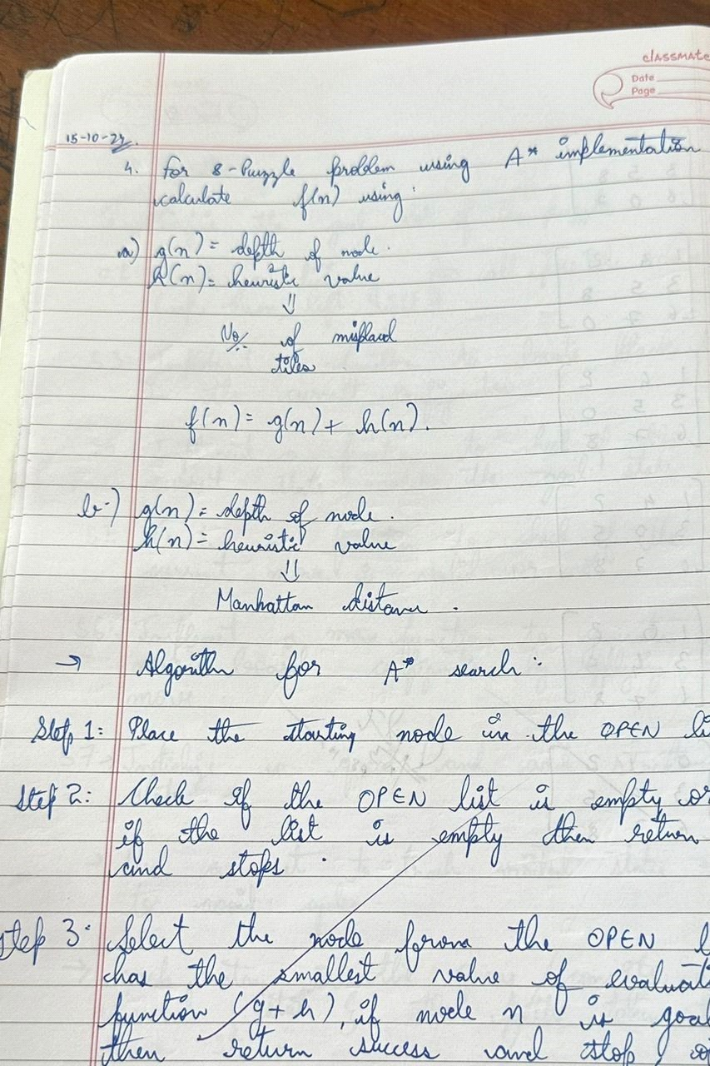

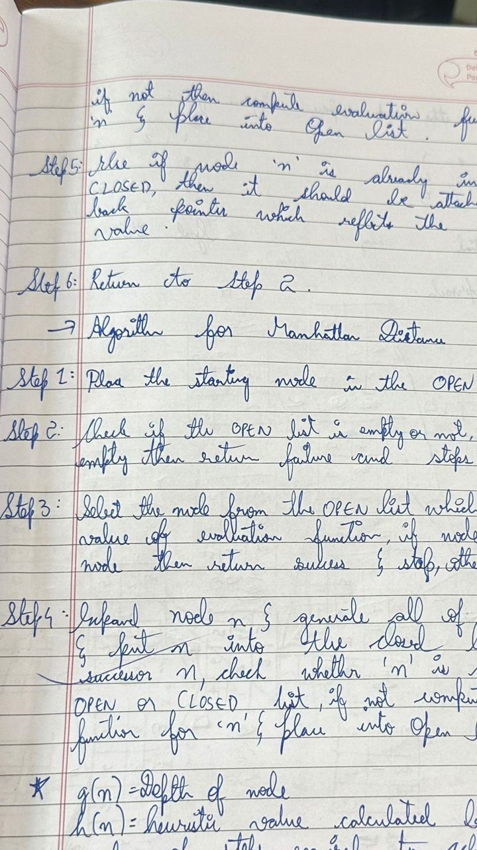

Code: import heapq

GOAL_STATE = ((1, 2, 3),

(8, 0, 4), (7, 6, 5))

def manhattan_distance(state):

distance = 0 for i in range(3): for j in range(3): value = state[i][j] if value != 0:

goal_x, goal_y = divmod(value - 1, 3) distance += abs(goal_x - i) + abs(goal_y - j) return distance def find_blank(state): for i in range(3): for j in range(3):

if state[i][j] == 0:

return i, j def generate_neighbors(state): neighbors = [] x, y = find_blank(state) directions = [(0, 1), (0, -1), (1, 0), (-1, 0)]

for dx, dy in directions: nx, ny = x + dx, y + dy if 0 <= nx < 3 and 0 <= ny < 3:

new_state = [list(row) for row in state]

new_state[x][y], new_state[nx][ny] = new_state[nx][ny], new_state[x][y] neighbors.append(tuple(tuple(row) for row in new_state)) return neighbors

def reconstruct_path(came_from, current):

path = [current] while current in came_from: current = came_from[current] path.append(current) path.reverse()

return path

def a_star(start): open_list = [] heapq.heappush(open_list, (manhattan_distance(start), 0, start))

g_score = {start: 0}

came_from = {}

visited = set()

while open_list:

f, g, current = heapq.heappop(open_list)

if current == GOAL_STATE:

path = reconstruct_path(came_from, current) return path, g

visited.add(current) for neighbor in generate_neighbors(current):

if neighbor in visited:

continue

tentative_g = g_score[current] + 1

if tentative_g < g_score.get(neighbor, float('inf')):

came_from[neighbor] = current g_score[neighbor] = tentative_g

f_score = tentative_g + manhattan_distance(neighbor) heapq.heappush(open_list, (f_score, tentative_g, neighbor))

return None, None

def print_state(state): for row in state: print(row)

print()

if __name__ == "__main__":

start_state = ((2, 8, 3),

(1, 6, 4),

(7, 0, 5))

print("Initial State:")

print_state(start_state)

print("Goal State:")

print_state(GOAL_STATE)

solution, cost = a_star(start_state)

if solution:

print(f"Solution found with cost: {cost}")

print("Steps:") for step in solution: print_state(step) else: print("No solution found.")Output:

Initial State: (2, 8, 3)

(1, 6, 4)

(7, 0, 5)

Goal State:

(1, 2, 3)

(8, 0, 4)

(7, 6, 5)

Solution found with cost: 5 Steps:

(2, 8, 3)

(1, 6, 4)

(7, 0, 5)

(2, 8, 3)

(1, 0, 4)

(7, 6, 5)

(2, 0, 3)

(1, 8, 4)

(7, 6, 5)

(0, 2, 3)

(1, 8, 4)

(7, 6, 5)

(1, 2, 3)

(0, 8, 4)

(7, 6, 5)

(1, 2, 3)

(8, 0, 4)

(7, 6, 5) Program 4

Implement Hill Climbing search algorithm to solve N-Queens problem

Algorithm:

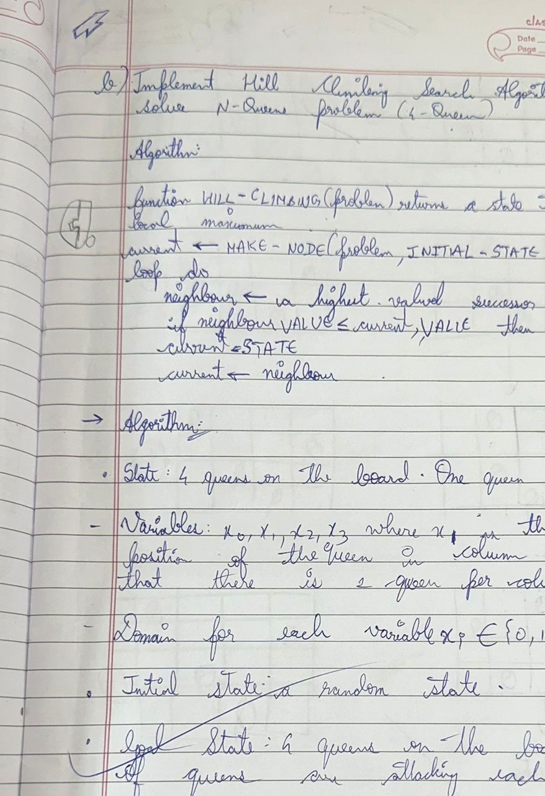

Code:

import random

def get_attacking_pairs(state):

"""Calculates the number of attacking pairs of queens.""" attacks = 0 n = len(state) for i in range(n):

for j in range(i + 1, n): if state[i] == state[j]:

attacks += 1 if abs(state[i] - state[j]) == abs(i - j):

attacks += 1 return attacks

def generate_successors(state):

"""Generates all possible successors by moving each queen to every other column in its row.""" n = len(state) successors = [] for row in range(n): for col in range(n): if col != state[row]: new_state = state[:] new_state[row] = col successors.append(new_state) return successors

def hill_climbing(n):

"""Hill climbing algorithm for n-queens problem.""" current = [random.randint(0, n - 1) for _ in range(n)] while True:

current_attacks = get_attacking_pairs(current) successors = generate_successors(current) neighbor = min(successors, key=get_attacking_pairs) neighbor_attacks = get_attacking_pairs(neighbor) if neighbor_attacks >= current_attacks:

return current, current_attacks current = neighbor

def print_board(state):

"""Prints the board with queens placed."""

n = len(state) board = [["." for _ in range(n)] for _ in range(n)] for row in range(n):

board[row][state[row]] = "Q" for row in board:

print(" ".join(row)) print("\n")

n = 4 solution, attacks = hill_climbing(n) print("Final State (Solution):", solution) print("Number of Attacking Pairs:", attacks) print_board(solution)

Output:

Final State (Solution): [3, 0, 2, 1]

Number of Attacking Pairs: 1

. . . Q Q . . . . . Q .

. Q . .

Program 5

Simulated Annealing to Solve 8-Queens problem

Algorithm:

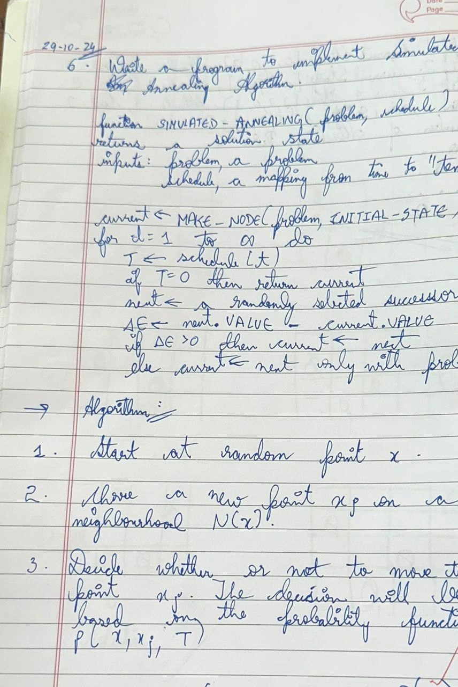

Code:

def print_board(board): for row in board:

print(" ".join(str(num) for num in row))

def is_valid(board, row, col, num):

# Check if the number is not in the current row and column for i in range(9): if board[row][i] == num or board[i][col] == num: return False

# Check the 3x3 grid start_row, start_col = 3 * (row // 3), 3 * (col // 3) for i in range(3): for j in range(3): if board[start_row + i][start_col + j] == num:

return False

return True

def solve_sudoku(board):

empty = find_empty_location(board) if not empty:

return True # Puzzle solved

row, col = empty

for num in range(1, 10): if is_valid(board, row, col, num):

board[row][col] = num

if solve_sudoku(board):

return True

# Reset the cell (backtrack)

board[row][col] = 0

return False # Trigger backtracking

def find_empty_location(board): for i in range(9): for j in range(9): if board[i][j] == 0:

return (i, j) # Return row, col

return None

# Example Sudoku puzzle (0 represents empty cells) sudoku_board = [

[5, 3, 0, 0, 7, 0, 0, 0, 0],

[6, 0, 0, 1, 9, 5, 0, 0, 0],

[0, 9, 8, 0, 0, 0, 0, 6, 0],

[8, 0, 0, 0, 6, 0, 0, 0, 3],

[4, 0, 0, 8, 0, 3, 0, 0, 1],

[7, 0, 0, 0, 2, 0, 0, 0, 6],

[0, 6, 0, 0, 0, 0, 2, 8, 0],

[0, 0, 0, 4, 1, 9, 0, 0, 5],

[0, 0, 0, 0, 8, 0, 0, 7, 9]

]

if solve_sudoku(sudoku_board): print("Sudoku solved successfully:") print_board(sudoku_board) else:

print("No solution exists.") Output:

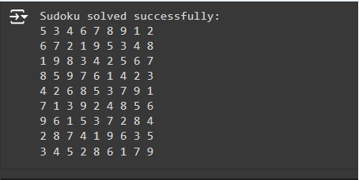

Program 6

Create a knowledge base using propositional logic and show that the given query entails the knowledge base or not.

Algorithm

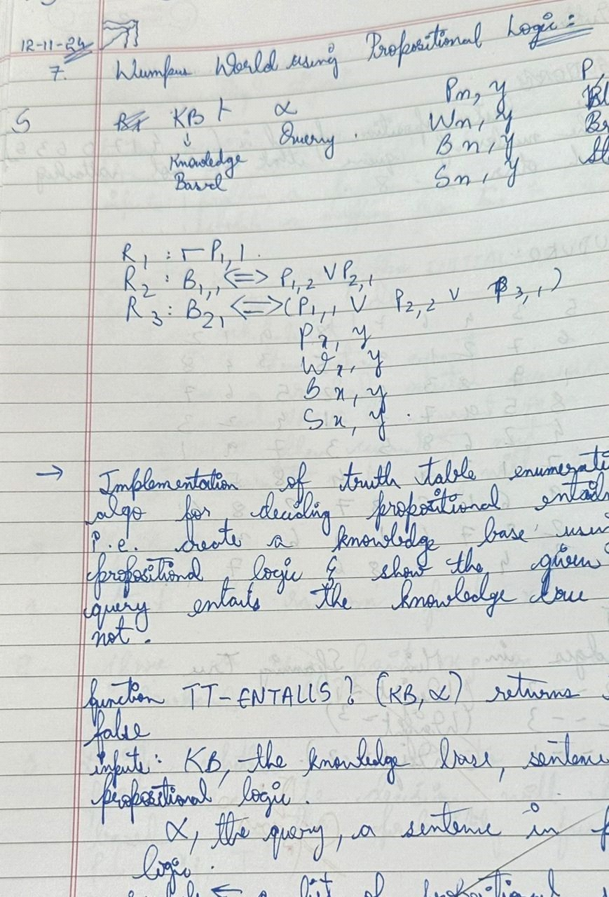

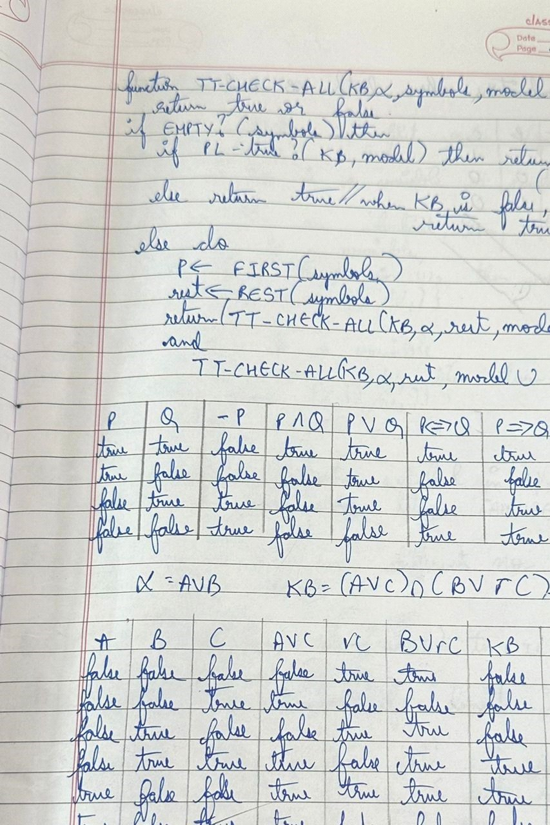

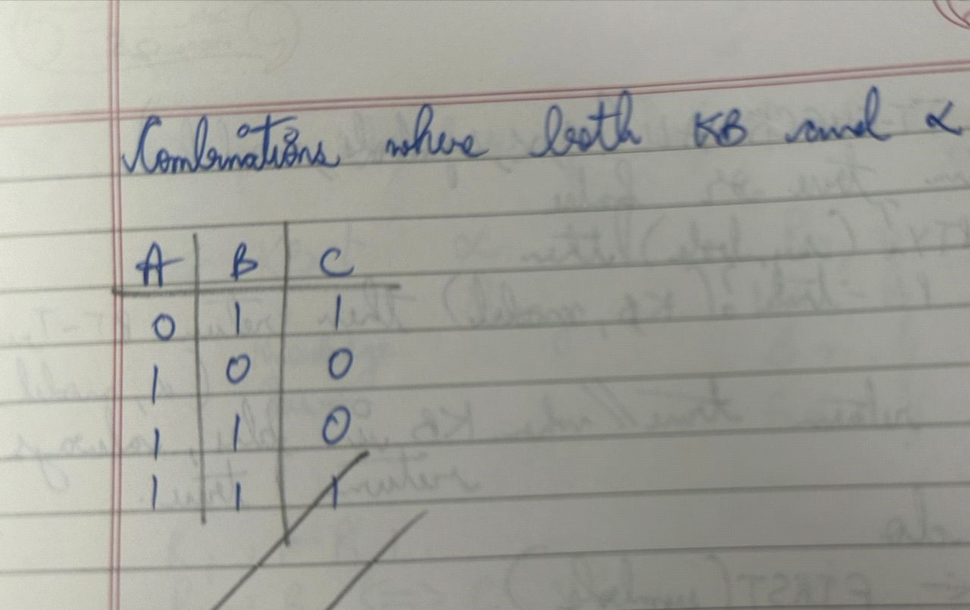

Code:

import itertools

def evaluate_formula(formula, valuation):

"""

Evaluate the propositional formula under the given truth assignment (valuation). The formula is a string of logical operators like 'AND', 'OR', 'NOT', and can contain variables 'A', 'B', 'C'.

"""

# Create a local environment (dictionary) for variable assignments env = {var: valuation[i] for i, var in enumerate(['A', 'B', 'C'])}

# Replace logical operators with Python equivalents

formula = formula.replace('AND', 'and').replace('OR', 'or').replace('NOT', 'not')

# Replace variables in the formula with their corresponding truth values for var in env:

formula = formula.replace(var, str(env[var]))

# Evaluate the formula and return the result (True or False) try:

return eval(formula) except Exception as e:

raise ValueError(f"Error in evaluating formula: {e}")

def truth_table(variables):

"""

Generate all possible truth assignments for the given variables.

"""

return list(itertools.product([False, True], repeat=len(variables)))

def entails(KB, alpha):

"""

Decide if KB entails alpha using a truth-table enumeration algorithm.

KB is a propositional formula (string), and alpha is another propositional formula (string).

"""

# Generate all possible truth assignments for A, B, and C assignments = truth_table(['A', 'B', 'C'])

print(f"{'A':<10}{'B':<10}{'C':<10}{'KB':<15}{'alpha':<15}{'KB entails alpha?'}") # Header for the truth table print("-" * 70) # Separator for readability

for assignment in assignments:

# Evaluate KB and alpha under the current assignment KB_value = evaluate_formula(KB, assignment) alpha_value = evaluate_formula(alpha, assignment)

# Print the current truth assignment and the results for KB and alpha print(f"{str(assignment[0]):<10}{str(assignment[1]):<10}{str(assignment[2]):<10}{str(KB_v alue):<15}{str(alpha_value):<15}{'Yes' if KB_value and alpha_value else 'No'}")

# If KB is true and alpha is false, then KB does not entail alpha if KB_value and not alpha_value:

return False

# If no counterexample was found, then KB entails alpha return True

# Define the formulas for KB and alpha alpha = 'A OR B'

KB = '(A OR C) AND (B OR NOT C)'

# Check if KB entails alpha

result = entails(KB, alpha)

# Print the final result of entailment

print(f"\nDoes KB entail alpha? {result}")

Output:

A B C KB alpha KB entails alpha?

----------------------------------------------------------------------

False False False False False No False False True False False No

False True False False True No

False True True True True Yes

True False False True True Yes

True False True False True No

True True False True True Yes

True True True True True Yes

Does KB entail alpha? True

Program 7:

Implement unification in first order logic

Algorithm:

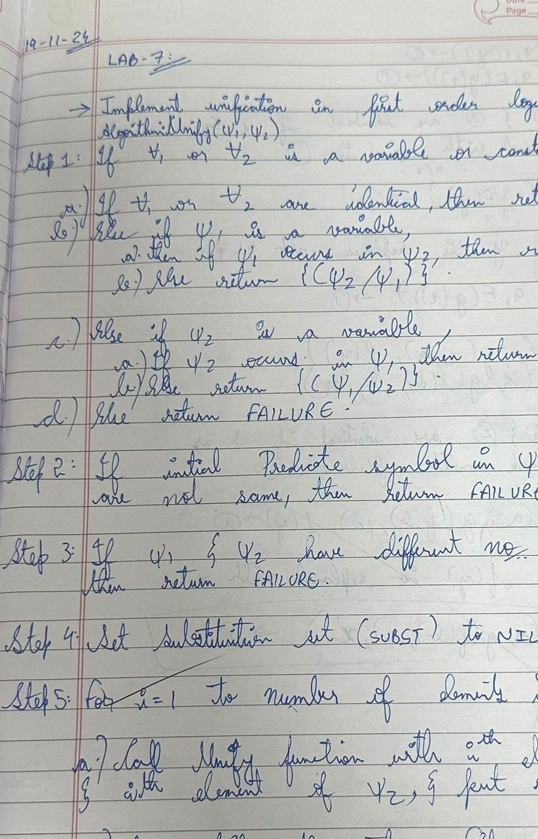

Code:

def unify(term1, term2):

"""

Unifies two terms using the unification algorithm.

Args:

term1: The first term. term2: The second term.

Returns:

A substitution set if the terms are unifiable, otherwise None. """

# Step 1: Handle variables and constants if isinstance(term1, str) or isinstance(term2, str): if term1 == term2: return {} # NIL elif term1.isupper(): # term1 is a variable if term1 in term2: return None # FAILURE return {term1: term2} elif term2.isupper(): # term2 is a variable if term2 in term1: return None # FAILURE return {term2: term1} else:

return None # FAILURE

# Step 2: Check predicate symbols if term1[0] != term2[0]: return None # FAILURE

# Step 3: Check number of arguments if len(term1[1:]) != len(term2[1:]):

return None # FAILURE

# Step 4: Initialize substitution set substitution_set = {}

# Step 5: Recursively unify arguments for i in range(len(term1[1:])):

result = unify(term1[1:][i], term2[1:][i]) if result is None:

return None # FAILURE else:

substitution_set = apply_substitution(substitution_set, result)

# Step 6: Return substitution set

return substitution_set

def apply_substitution(substitution_set, new_substitution):

"""

Applies a new substitution to the existing substitution set.

Args:

substitution_set: The current substitution set.

new_substitution: The new substitution to be applied.

Returns:

The updated substitution set. """

for var, value in new_substitution.items(): # Apply the new substitution to the existing values for key, val in substitution_set.items():

# Replace variables in the existing substitution set if key == var:

substitution_set[key] = value elif isinstance(val, str) and val == var:

substitution_set[key] = value

# Add the new substitution to the set

substitution_set[var] = value

return substitution_set

def parse_term(term_str):

"""

Parses a term string into a structured format.

Args:

term_str: The string representation of the term.

Returns:

A structured term (list).

""" term_str = term_str.strip() if '(' not in term_str:

return term_str # Return variable or constant

# Split the term into the function and its arguments func_name, args_str = term_str.split('(', 1)

args_str = args_str.rstrip(')') # Remove the closing parenthesis

# Split arguments by commas, accounting for nested terms args = [] bracket_count = 0

current_arg = []

for char in args_str:

if char == ',' and bracket_count == 0: args.append(''.join(current_arg).strip()) current_arg = [] else: if char == '(':

bracket_count += 1 elif char == ')':

bracket_count -= 1

current_arg.append(char)

if current_arg:

args.append(''.join(current_arg).strip())

return [func_name] + [parse_term(arg) for arg in args]

def apply_substitution_to_term(term, substitution_set):

"""

Applies a substitution set to a term.

Args:

term: The term to which the substitution is applied. substitution_set: The substitution set.

Returns:

The term after applying substitutions.

""" if isinstance(term, str):

return substitution_set.get(term, term) # Return the substituted value or the term itself

# Apply substitution recursively to the term's components return [term[0]] + [apply_substitution_to_term(arg, substitution_set) for arg in term[1:]]

def main():

# Take input from the user for the expressions term1_str = input("Enter the first term : ")

term2_str = input("Enter the second term: ")

# Parse the input terms term1 = parse_term(term1_str) term2 = parse_term(term2_str)

# Perform unification

substitution_set = unify(term1, term2)

if substitution_set is not None:

# Apply the substitution to the original terms unified_term1 = apply_substitution_to_term(term1, substitution_set) unified_term2 = apply_substitution_to_term(term2, substitution_set)

# Print the final unified expressions print("Unified Term 1:", unified_term1) print("Unified Term 2:", unified_term2) else:

print("The terms are not unifiable.")

if __name__ == "__main__": main()

Output:

Enter the first term : f(X,f(Y))

Enter the second term: f(a,f(g(X))

Unified Term 1: ['f', 'a', ['f', ['g', 'X']]]

Unified Term 2: ['f', 'a', ['f', ['g', 'a']]]

Enter the first term : f(f(a,g(Y)) Enter the second term: f(X,X) The terms are not unifiable.

Program 8:

Create a knowledge base consisting of irst order logic statements and prove the given query using forward reasoning.

Algorithm:

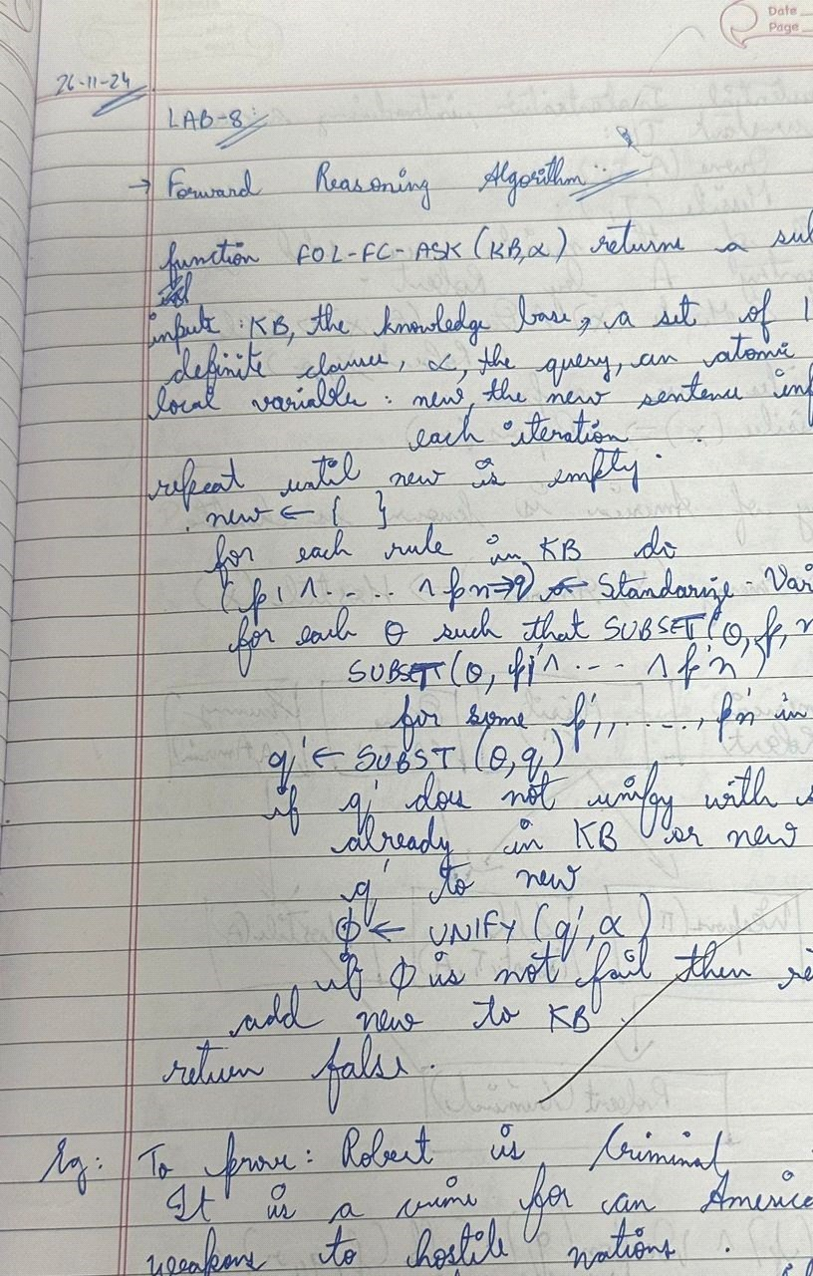

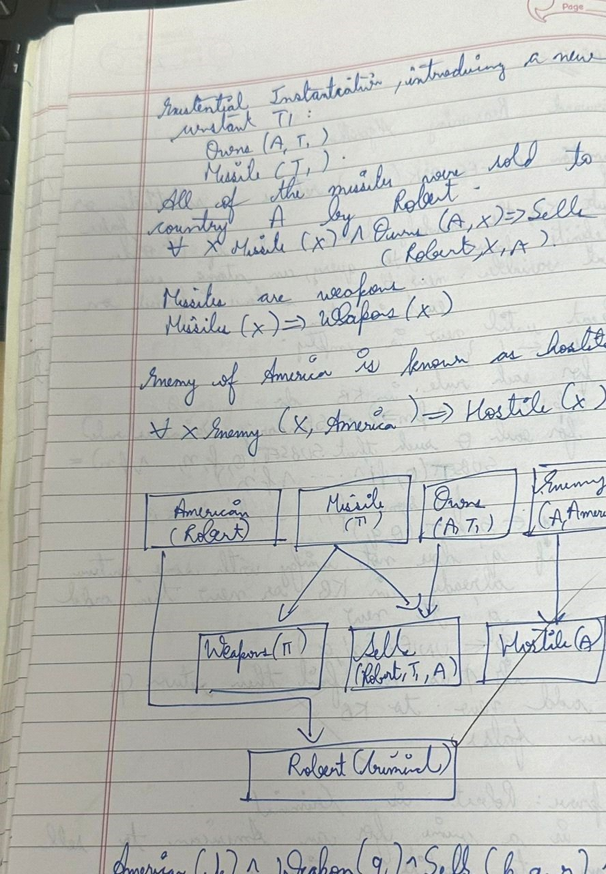

Code:

# Define the knowledge base as a list of rules and facts

class KnowledgeBase: def __init__(self):

self.facts = set() # Set of known facts

self.rules = [] # List of rules

def add_fact(self, fact): self.facts.add(fact)

def add_rule(self, rule): self.rules.append(rule)

def infer(self): inferred = True while inferred: inferred = False for rule in self.rules: if rule.apply(self.facts):

inferred = True

# Define the Rule class class Rule: def __init__(self, premises, conclusion):

self.premises = premises # List of conditions self.conclusion = conclusion # Conclusion to add if premises are met

def apply(self, facts): if all(premise in facts for premise in self.premises): if self.conclusion not in facts: facts.add(self.conclusion) print(f"Inferred: {self.conclusion}")

return True

return False

# Initialize the knowledge base

kb = KnowledgeBase()

# Facts in the problem kb.add_fact("American(Robert)") kb.add_fact("Missile(T1)") kb.add_fact("Owns(A, T1)")

kb.add_fact("Enemy(A, America)")

# Rules based on the problem # 1. Missile(x) implies Weapon(x)

kb.add_rule(Rule(["Missile(T1)"], "Weapon(T1)"))

# 2. Enemy(x, America) implies Hostile(x)

kb.add_rule(Rule(["Enemy(A, America)"], "Hostile(A)"))

# 3. Missile(x) and Owns(A, x) imply Sells(Robert, x, A) kb.add_rule(Rule(["Missile(T1)", "Owns(A, T1)"], "Sells(Robert, T1, A)"))

# 4. American(p) and Weapon(q) and Sells(p, q, r) and Hostile(r) imply Criminal(p) kb.add_rule(Rule(["American(Robert)", "Weapon(T1)", "Sells(Robert, T1, A)",

"Hostile(A)"], "Criminal(Robert)"))

# Infer new facts based on the rules

kb.infer()

# Check if Robert is a criminal if "Criminal(Robert)" in kb.facts:

print("Conclusion: Robert is a criminal.") else:

print("Conclusion: Unable to prove Robert is a criminal.")

Output:

Inferred: Weapon(T1)

Inferred: Hostile(A)

Inferred: Sells(Robert, T1, A) Inferred: Criminal(Robert) Conclusion: Robert is a criminal.

Program 9:

Create a knowledge base consisting of irst order logic statements and prove the given query using Resolution

Algorithm:

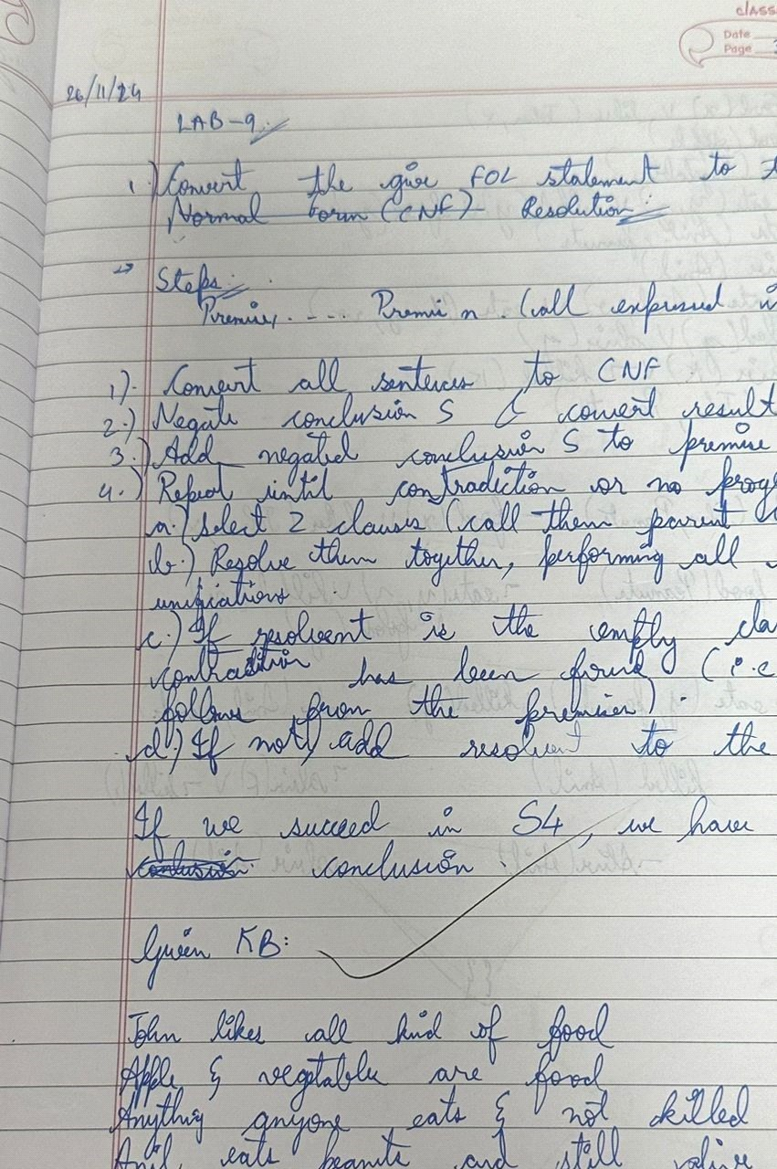

Code:

class CNFReasoner: def __init__(self, clauses):

"""

Initializes the CNF Reasoner.

Parameters:

clauses (list of sets): List of clauses in CNF format.

"""

self.clauses = [set(clause) for clause in clauses]

def resolve(self, clause1, clause2):

"""

Resolve two clauses to produce new clauses if possible.

Parameters:

clause1 (set): The first clause (set of literals). clause2 (set): The second clause (set of literals).

Returns:

list: A list of resolved clauses (sets of literals).

""" resolvents = [] for literal in clause1:

neg_literal = f"~{literal}" if not literal.startswith("~") else literal[1:] if neg_literal in clause2:

# Create a new clause by removing complementary literals new_clause = (clause1 - {literal}) | (clause2 - {neg_literal}) resolvents.append(new_clause) return resolvents

def infer(self, goal):

"""

Infer whether the goal is provable using resolution.

Parameters:

goal (set): The negation of the goal to be proved.

Returns:

bool: True if the goal is provable, False otherwise.

"""

goal_clause = {f"~{literal}" for literal in goal} clauses = self.clauses + [goal_clause] # Add the negated goal to clauses new = set()

while True: pairs = [(clauses[i], clauses[j]) for i in range(len(clauses)) for j in range(i + 1, len(clauses))] for (clause1, clause2) in pairs:

resolvents = self.resolve(clause1, clause2) for resolvent in resolvents:

if not resolvent: # Found an empty clause, goal is proved return True new.add(frozenset(resolvent))

# Check if no new information is being added if new.issubset(set(map(frozenset, clauses))):

return False

# Add new resolvents to the clauses for clause in new:

if clause not in clauses:

clauses.append(set(clause))

# Define the CNF clauses based on the FOL premises cnf_clauses = [

{"~Food(X)", "Likes(John, X)"}, # Rule 1: If Food(X), then Likes(John, X)

{"~Eats(Anil, Peanuts)", "Food(Peanuts)"}, # Rule 2.1: If Anil eats peanuts, peanuts are food

{"~Alive(Anil)", "Food(Peanuts)"}, # Rule 2.2: If Anil is alive, peanuts are food {"~Food(Peanuts)", "Likes(John, Peanuts)"}, # Rule 3: If peanuts are food, John likes peanuts

{"Eats(Anil, Peanuts)"}, # Fact 1: Anil eats peanuts

{"Alive(Anil)"}, # Fact 2: Anil is alive

]

# Define the goal: Prove that John likes peanuts goal = {"Likes(John, Peanuts)"}

# Initialize the reasoner and infer reasoner = CNFReasoner(cnf_clauses) if reasoner.infer(goal):

print("Proved: John likes peanuts.") else:

print("Could not prove: John likes peanuts.")

Output:

Proved: John likes peanuts.

Program 10:

Implement Alpha-Beta Pruning.

Algorithm:

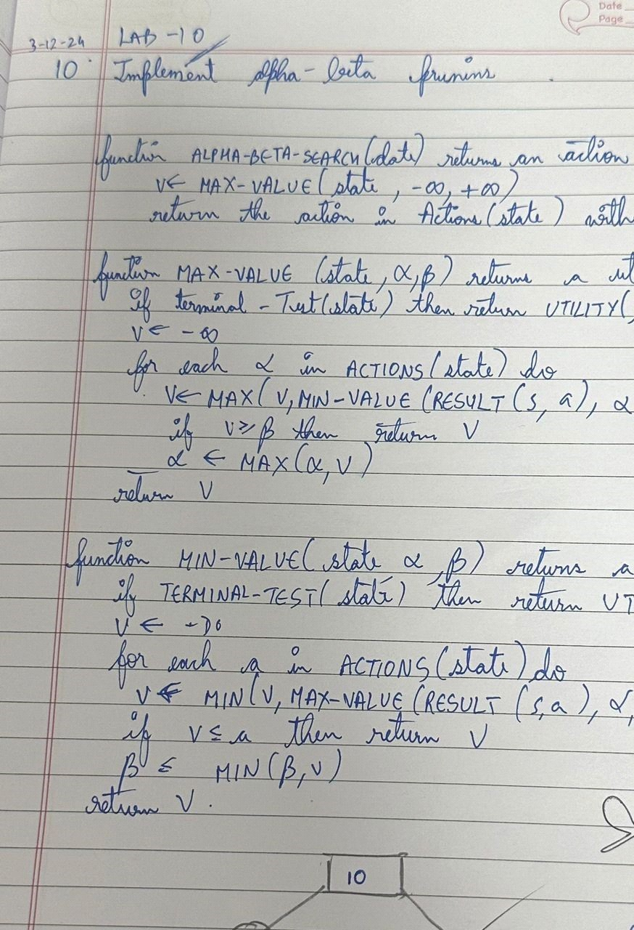

Code: import math

def minimax(depth, index, maximizing_player, values, alpha, beta):

# Base case: when we've reached the leaf nodes if depth == 0:

return values[index]

if maximizing_player: max_eval = float('-inf') for i in range(2): # 2 children per node eval = minimax(depth - 1, index * 2 + i, False, values, alpha, beta) max_eval = max(max_eval, eval) alpha = max(alpha, eval) if beta <= alpha: # Beta cutoff

break return max_eval else:

min_eval = float('inf')

for i in range(2): # 2 children per node eval = minimax(depth - 1, index * 2 + i, True, values, alpha, beta) min_eval = min(min_eval, eval) beta = min(beta, eval) if beta <= alpha: # Alpha cutoff

break

return min_eval

# Accept values from the user leaf_values = list(map(int, input("Enter the leaf node values separated by spaces: ").split()))

# Check if the number of values is a power of 2 if math.log2(len(leaf_values)) % 1 != 0:

print("Error: The number of leaf nodes must be a power of 2 (e.g., 2, 4, 8, 16).") else:

# Calculate depth of the tree

tree_depth = int(math.log2(len(leaf_values)))

# Run Minimax with Alpha-Beta Pruning optimal_value = minimax(depth=tree_depth, index=0, maximizing_player=True, values=leaf_values, alpha=float('-inf'), beta=float('inf'))

print("Optimal value calculated using Minimax:",optimal_value)

Output:

Enter the leaf node values separated by spaces: -1 8 -3 -1 2 1 -3 4

Optimal value calculated using Minimax: 2